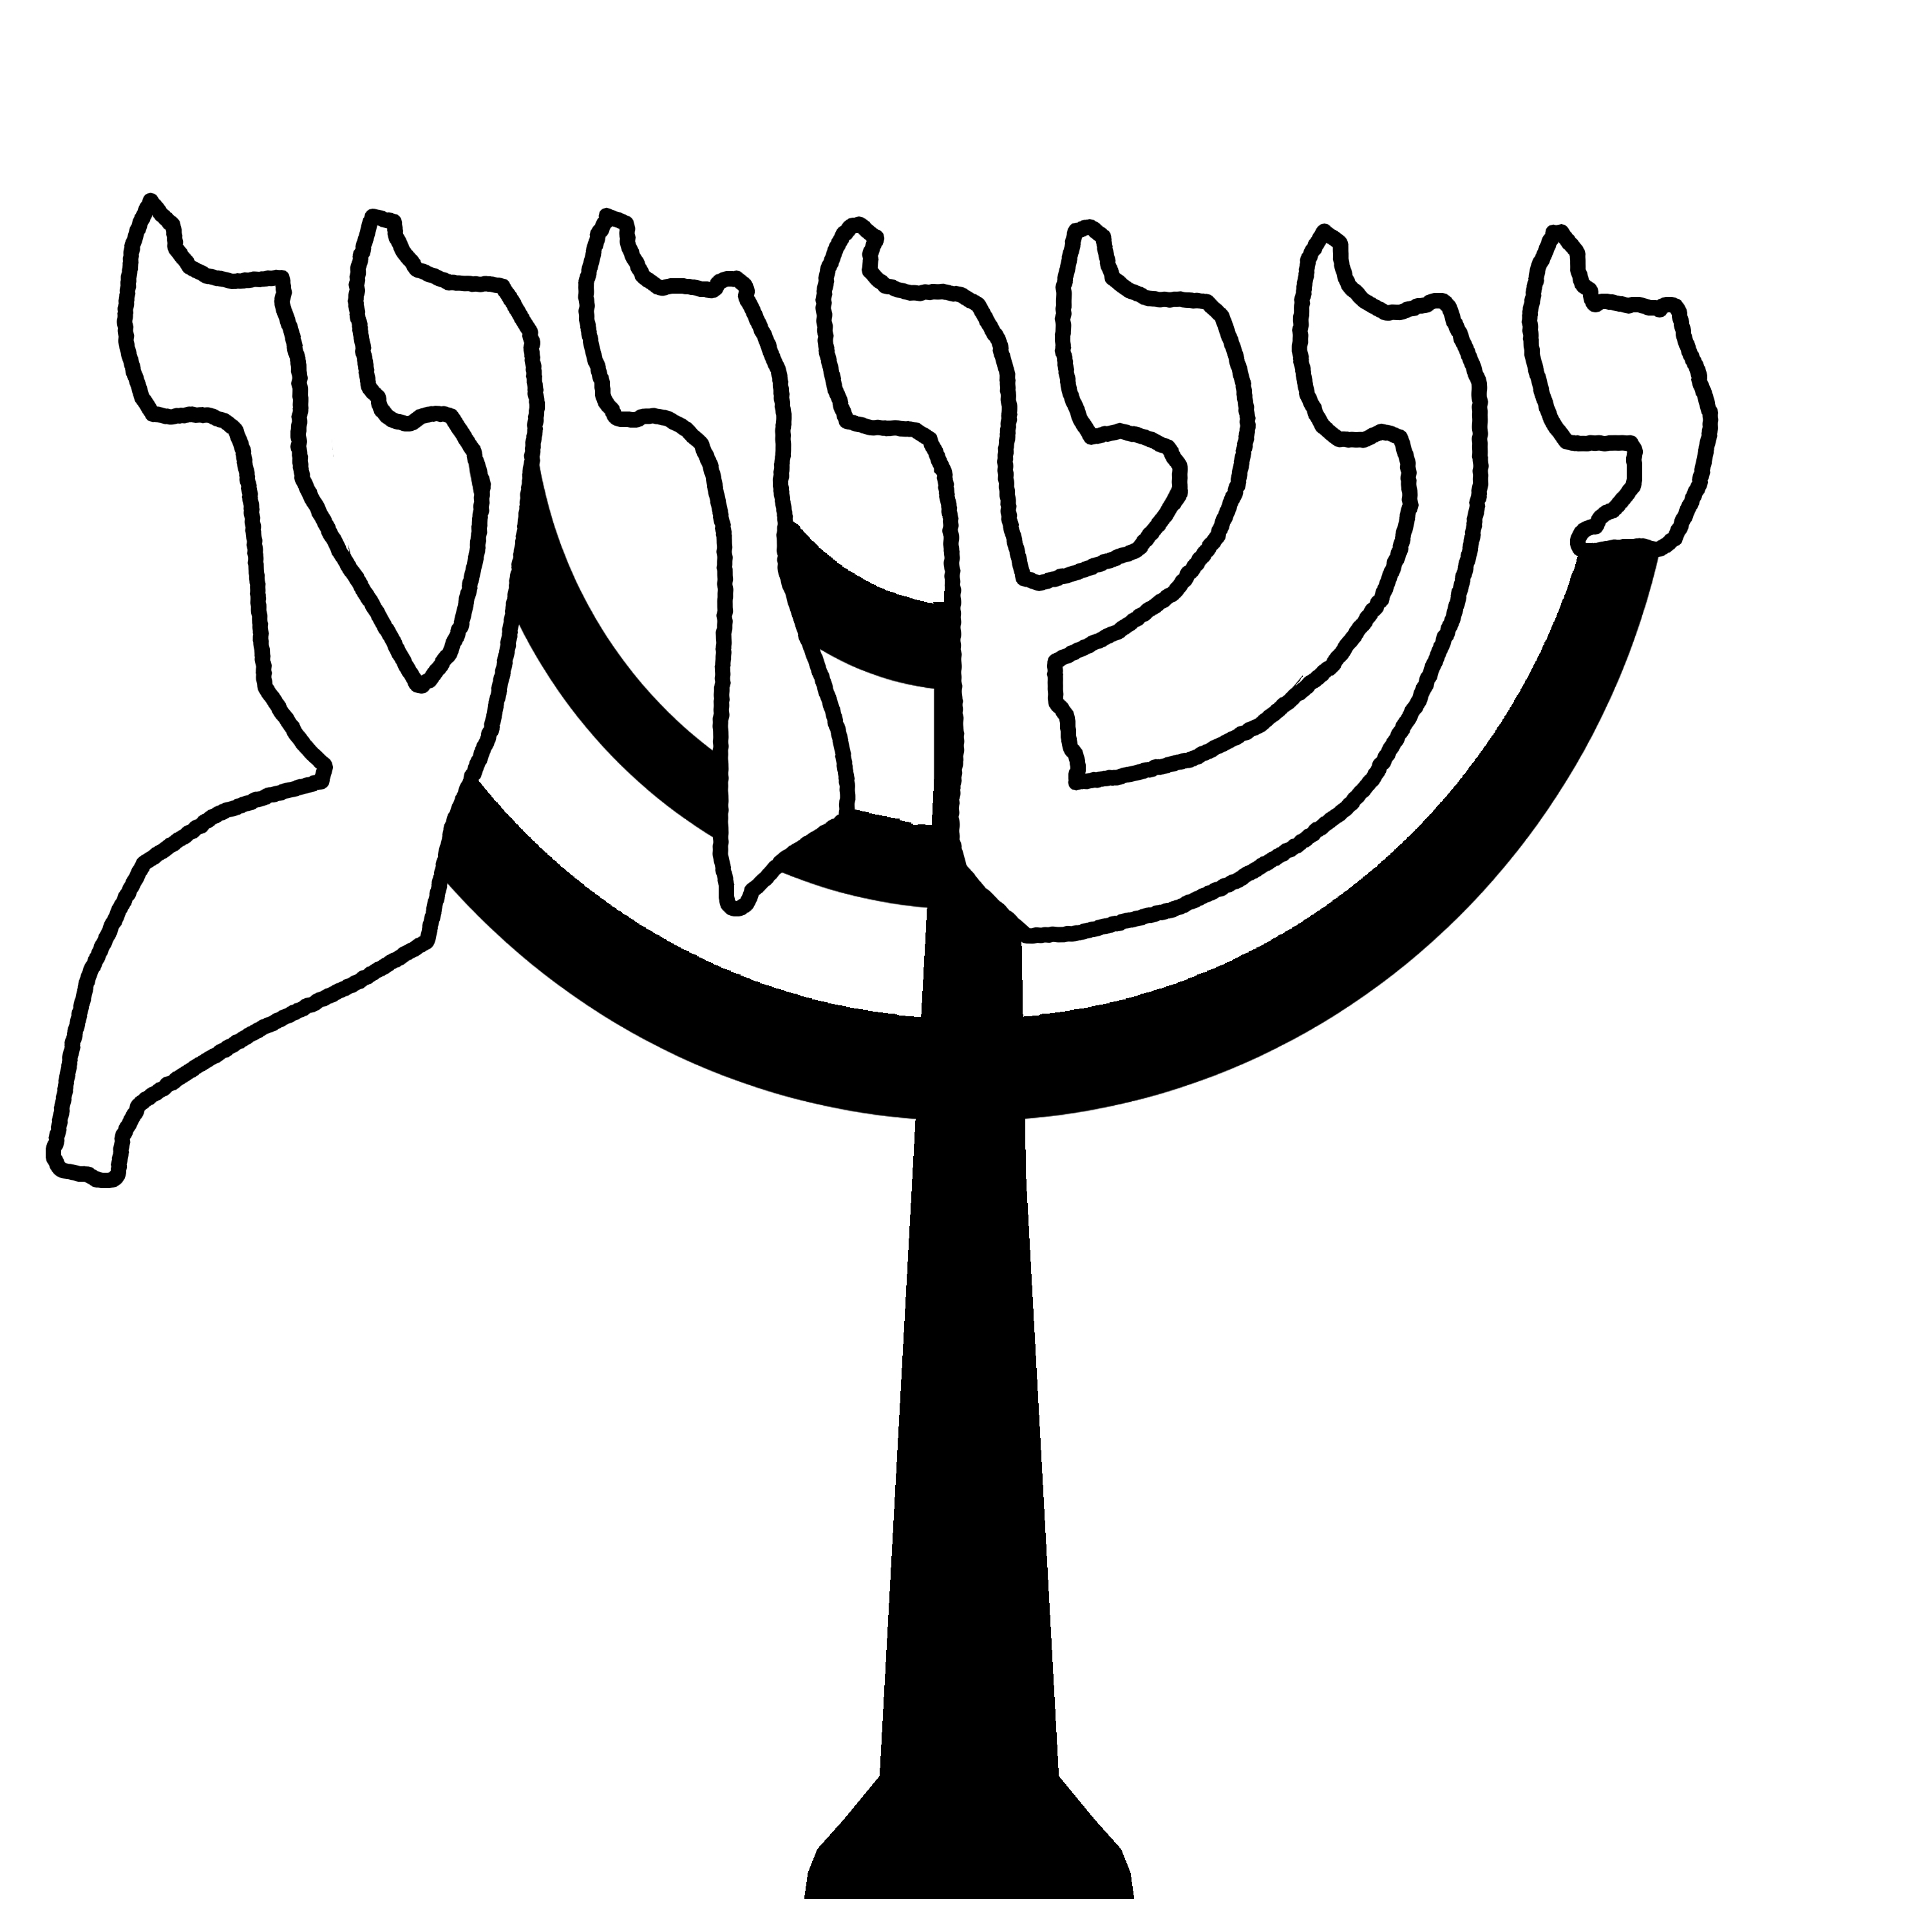
י א YUD ALEPH
Before I start this lesson on the י Yud, allow me to show you some things of interest.

As we all know, the Jewish people are descended from the Three Patriarchs….Abraham, Isaac, and Jacob, and the Four Matriarchs, Sarah, Rebecca, Rachel, and Leah.

It is their greatness and holiness that have been transmitted to every one of the “Children of Israel.”

Here we go….The name יִשְׁרָאֵל (Yisrael) bears within it the acronym for every one of our spiritual forebears:

י Yud יִעְקֹב יִצְחָק (Ya’akov, Yizhak) (Jacob…Isaac)
ש Shin שָׂרָה (Sarah)
ר Reysh רָחֵל רִבְקָה (Rachel, Rivkah) …(Rachel…..Rebecca)
א Aleph אַבְרָהָם (Avraham)
ל Lamed לֵאָה (Leah)

I want to point out, and in part I will repeat some information, but the smallest letter in the Hebrew alephbet is the letter we are studying, the י Yud. Let me also say that the letter ל is the largest and tallest of all the Hebrew letters.

Since everything G-d does, has a purpose. So, as we look at the word יִשְׁרָאֵל (Yisrael) we see that in the very name of Jewish people, alludes to both its humble beginnings as well as its glorious destiny.

There is a scripture that alludes to this…Ready? בְּרֵאשִׁית Genesis 12:2…”Yet the smallest in number will be blessed beyond any other and I will make of thee a great nation and I will bless thee and make thy name great”

That greatness shall come through the very meaning of the letter ל ..lamed of which we will study down the way, means to ‘teach’. We shall be the teachers of the world, “a kingdom of priests,” hastening the arrival of that day when all humankind will proclaim that our L-rd is One and His name is One.

Permit me to go a little deeper…..and I will repeat in some form of this later….The Ten Commandments were given to the Jewish people on two tables. All of Jewish Law summarized within the Decalogue was divided into two categories: the first five commandments deal with the obligations of MAN TO G-D ….the second five relate to responsibilities of MAN TO FELLOW MAN.

Interestingly the Hebrew root for honesty and straightforwardness in human relationships is the word יָשָׂר (yashar). Did you notice that this is the first part of the word יִשְׁרָאֵל (Yisrael)?...Let’s go further…and add to that word יָשָׂר (yashar). The awareness of G-d, He whose Hebrew name is אֵל (El), and together we have not only our name but also the statement of our mission….to BLESS as stated in בְּרֵאשִׁית Genesis 12:2

Let me give one more example of how letters of the alephbet combine with the plan of G-d, and then we will go into our lesson…amen?

Let’s dissect the name יִצְחָק Yizhak ISAAC.
Four letters define the son of Abraham the Patriarch and allude to his greatness. Let’s do the ‘numbers game.”

י yud 10, referring to the Ten Commandments.
צ Tzadi 90, the age of Sarah at which she miraculously bore
Isaac
ח Chet 8, the day when Isaac was circumcised and given his
name יִצְחָק Yizhak
ק Kof 100, the age of Abraham, his father, at the time when her sired him.

A miracle performed for a mother and father, respectively aged 90 and 100, was for the sake of a child who would be circumcised and enter a covenant subsequently defined at Sinai through the Ten Commandments.

Well, let’s get started with our lesson on the powerful letter י YUD!!!

י – YUD.. Carries the value of 10. The tenth letter is barely larger than a dot and cannot be divided into component parts. It alludes to G-d who is One and Indivisible. Therefore by itself means G-d…(also represents the HAND of G-d)….and is used to form all the other letters, so G-d is everywhere in His language or Word. Yud is the first letter of His Divine name YHVH. יהוה

Oh, I can’t let this pass us by. הָיָה (hayah) means WAS.
הֹוֶה (hoveh) means IS
יִהְיֶה (yiheyeh) means WILL BE.

So, if you combine the words for being in the PAST, PRESENT, AND FUTURE, you get the four-letter name of G-d, by which He is known in the Torah. יהוה He occupies all of the time simultaneously even as He occupies all of space….the entire universe is filled with His Glory…..amen?

Let’s proceed with the lesson…..this is good stuff…………

The י yud consists of 3 parts. A prong pointing upwards to the ONE above, and a prong directed downwards to earth and the middle part uniting both. The shape of the י yud is symbolic of a person in prayer. His eyes are lowered in humility as he stands before the King, while his heart is directed upward, toward heaven. The א aleph is also three parts with the yud. So there are three parts in one…the divinity and pictures יֵשׁוּעַ as our humble Mediator before the Father. Check this out….the aleph א has a value of 26….2 yuds, one vav…yuds are 10 each and the vav is 6.

יהוה..JEHOVA י= 10..ה= 5….ו= 6….ה = 5 = 26 also…..add 2 and 6 = 8..new beginning

The י also can be seen as a hand reaching to heaven, and also a man in prayer with this tallit. The bent shape suggests submission.

